Mile High Spine and Sport
2530 S. Parker Rd. Suite 102 Aurora, CO 80014
O: (720)446-9998 ~ F: (303)306-0137

CASE HISTORY
Name: _________________________________

- Circle the severity (0 = No Pain to 10 = Very Severe Pain) and Frequency of pain (% of the week you experience the pain).

Condition / Problem Severity Frequency (% of week)
Minimal Severe Occasional Constant

a. 0 1 2 3 4 5 6 7 8 9 10 0 10 20 30 40 50 60 70 80 90 100

b. 0 1 2 3 4 5 6 7 8 9 10 0 10 20 30 40 50 60 70 80 90 100

c. 0 1 2 3 4 5 6 7 8 9 10 0 10 20 30 40 50 60 70 80 90 100

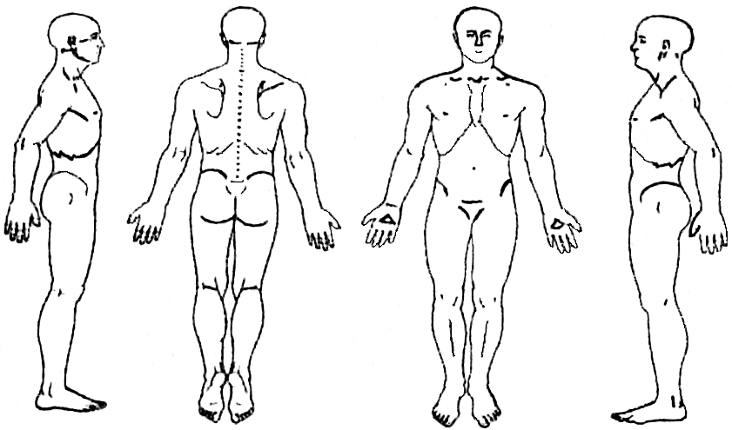
(Please mark the figures where you experience pain.)

- Symptoms are worse in the (circle what applies)

-morning -Increase during the day

-afternoon -same all day

-night -decrease during the day

- Symptom (a.) is: Sharp / Dull / Burning / Aching / Throbbing / Numbness / Tingling / Pins & Needles
- Symptom (b.) is: Sharp / Dull / Burning / Aching / Throbbing / Numbness / Tingling / Pins & Needles
- When did your symptoms begin (onset date)? __________________________________________________________
- How did your symptoms begin? _____________________________________________________________________
- Have you experienced these before? __________________________________________________________________
- Do your symptoms radiate? _________________________________________________________________________
- Has your condition? ____ Improved ____ Gotten Worse ____ Stayed the same since it began
- Circle the things that make your problems worse:
Bending - Lying - Walking - Standing - Sitting - Movement - Twisting - Lifting - Sleeping
- Is there anything you can do to relieve the problems? ____No ____Yes Describe: _____________________________
If No, what have you tried that has not helped? _________________________________________________
- Have you been treated for this before? ____No ____Yes How long ago? ___________________________________
- What treatment did you receive? _____________________________________________________________________
- Results of previous treatment? ____Good ____Poor Comments _________________________________________
- Were you referred to our office by anyone? _____________________________________________________________
- Is this condition interfering with ____ Work ____Sleep ____Daily Routine ____Recreation
- List any other major injuries you have had, other than those mentioned above: ________________________________
_______________________________________________________________________________________________________________________________________
- Any other Musculoskeletal problems? ____No ____Yes …Neurological problems? ____No ____ Yes
_____Additional information on back side of sheet.

I certify that the above information is accurate to the best of my knowledge.
Patient/Guardian Signature _________________________________________________ Date: ______________

